- Explain Virtualization in brief.
Answer: - Virtualization is the creation of a virtual (rather than actual) version of something, such as an operating system (OS), a server, a storage device or network resources. Virtualization uses software that simulates hardware functionality in order to create a virtual system.
We can divide this into two parts one for Storage Virtualization and other for Network Virtualization.
- Storage Virtualization:
It is the pooling of physical storage from multiple storage devices into what appears to be a single storage device or pool of available storage capacity that is managed from a central console. The virtual storage software intercepts I/O requests from physical or virtual machines and sends those requests to the appropriate physical location of the storage device that are part of the all pool of storage in the virtualized environment.
Types of Storage Virtualization: File-Based and Block-Based
- File-Based: is a specific use case, applied to network-attached storage (NAS) systems. Using the Server Message Block (SMB) or Network File System (NFS) protocols, file-based storage virtualization breaks the dependency in a normal NAS array between the data being accessed and the location of physical memory. This enables the NAS system to better handle file migration in the background to improve performance.
- Block-Based: It is more widely applied in virtual storage systems than file-based storage virtualization. Block-based systems abstract the logical storage, such as a drive partition, from the actual physical memory blocks in a storage device, such as a hard disk drive (HDD) or solid-state memory device. This enables the virtualization management software to collect the capacity of the available blocks of memory space and pool them into a shared resource to be assigned to any number of VMs, bare-metal servers or containers.
- Network Virtualization:
It refers to abstracting network resources traditionally delivered in hardware to software. It can combine multiple physical networks to one virtual, software-based network, or it can divide one physical network into separate, independent virtual networks.
Types of Network Virtualization: External Virtualization and Internal Virtualization
- External Virtualization: Combines multiple networks or parts of networks into a virtual unit.
- Internal Virtualization: Uses software containers to mimic or provide the functionality of a single physical network.
# Benefits of Network Virtualization:
- Reduced equipment costs and reduced power consumption.
- Better Scalability
- Running on multiple environments on the same infrastructure.
- Geographical Independence with the higher uniformity of the physical network platform.
- Explain classes of service are available in Fiber Channel?

Answer: - Fiber channel offers several connection strategies, called classes of service, for connecting devices through a Fiber Channel fabric. There are normally 6 classes defined for this which can be describe as below.
“Class 1 provides a dedicated connection between two ports including Fabric ports known as the Sequence Initiator and the Sequence Recipient. The connection has the full bandwidth available. Additionally, in most cases, a Class 1 connection does not allow other ports to access either of the participants. This ensures that the ports will not be busy. It also ensures that the Frames all arrive in the order they were sent which speeds up the re-assembly at the end. A Class 1 connection will remain active until either the Sequence Initiator or the Recipient closes it.
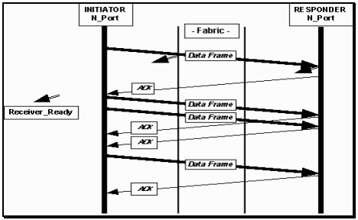

Class 1 data flow:
Note R_RDY on connect request only.

Class 2 provides a multiplexed service which allows for routing and flow control on a Frame by Frame basis. Additionally, it provides acknowledgment of Frame delivery. This allows interleaving of Sequences over the single connection from multiple N-Ports. A Class 2 connection may specify in-order-delivery to ensure that Frames arrive in the proper order.
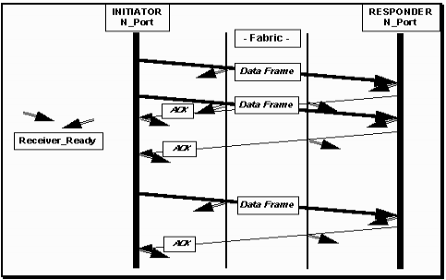

Class 2 data flow:
Note the ACK for every frame.
Also R_RDY
Class 3 provides a connectionless service with no acknowledgment. There is no confirmation that a Frame was received by the destination N-Port. There are no indications of Busy or Reject forms of acknowledgment either. This class breaks a major design objective of Fiber Channel which is to not deliver corrupt data (for example a Frame Header error) without some form of indication that it is corrupt. It essentially sacrifices reliability for performance. It is used in cases where the ULP it is supporting needs to perform its own error detection and correction.
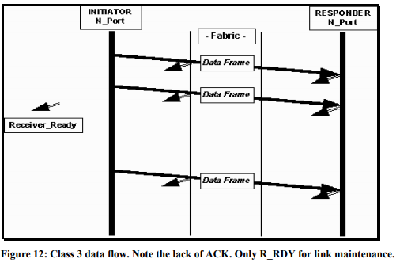
Besides these basic services, the Fiber Channel specification lists three other classes of service: Classes 4, 5 and 6. Class 4 allocates fractional bandwidth of a channel to establish a virtual circuit between two devices. Thus a single channel may serve many virtual circuits. Class 5 is not fully defined. Class 6 is multi-cast (one-to-many) transmission through the fabric.

- Explain the difference between LUN and WWN?

